**CS 5900/STAT 46700 Topics in Data Science Spring 2025**

**Homework 4**

**[Vaishak Balachandra]**

**Q.N. 1)** The data on the total spending of customers and their ages is provided below

ID: A, B, C, D, E, F, G, H, I, J, K, L, M, N, O, P, Q, R, S, T

Age: 18, 21, 22, 24, 26, 26, 27, 30, 31, 35, 39, 40, 41, 42, 44, 46, 47, 48, 49, 54

Spend: 10, 11, 22, 15, 12, 13, 14, 33, 39, 37, 44, 27, 29, 20, 28, 21, 30, 31, 23, 24

Perform the cluster analysis using the K-means clustering and Cluster Dendrogram and identify the members in three clusters.

> # Q1

>

> ID <- c('A','B','C','D','E','F','G','H','I','J','K','L','M','N','O','P','Q','R','S','T' )

> Age <- c(18, 21, 22, 24, 26, 26, 27, 30, 31, 35, 39, 40, 41, 42, 44, 46, 47, 48, 49, 54)

> Spend <- c(10, 11, 22, 15, 12, 13, 14, 33, 39, 37, 44, 27, 29, 20, 28, 21, 30, 31, 23, 24)

> Q1 <- data.frame(ID, Age, Spend)

> head(Q1)

ID Age Spend

1 A 18 10

2 B 21 11

3 C 22 22

4 D 24 15

5 E 26 12

6 F 26 13

> dim(Q1)

[1] 20 3

> names(Q1)

[1] "ID" "Age" "Spend"

>

> set.seed(037831852)

> kmeans_m1 <- kmeans(Q1[ , 2:3], centers = 3)

> kmeans_m1$cluster

[1] 1 1 2 2 2 2 2 3 3 3 3 3 3 3 3 3 3 3 3 3

> kmeans_m1$centers

Age Spend

1 19.5 10.50000

2 25.0 15.20000

3 42.0 29.69231

> kmeans_m1$size

[1] 2 5 13

> cat("Therefore, using 3 centered K-MEANS Clustering, we got 3 clusters:

+ 2 5 13")

Therefore, using 3 centered K-MEANS Clustering, we got 3 clusters:

2 5 13

>

> install.packages("factoextra")

> library(factoextra)

> rownames(Q1) <- Q1[, 1]

> # or

> # rownames(Q1) <- Q1$ID

> fviz_cluster(kmeans_m1, data=Q1[ , 2:3], main = "K-means Clustering with 3 Clusters", geom = "text", labelsize = 1.5)

> # also Dendogram splits

> split(Q1$ID, kmeans_m1$cluster)

$`1`

[1] "A" "B"

$`2`

[1] "C" "D" "E" "F" "G"

$`3`

[1] "H" "I" "J" "K" "L" "M" "N" "O" "P" "Q" "R" "S" "T"

**Q.N. 2)** The dataset USArrests in the base package contains statistics, in arrests per 100,000 residents for assault, murder, and rape in each of the 50 US states in 1973. Also given is the percent of the population living in urban areas.

**a)** Calculate the numerical summary of the variables provide in the dataset.

**b)** Use K-means clustering methods to determine the clusters of the states with similar rate of Murder, Assault, Urban Population, and Rape. Justify the number of clusters that you have chosen.

**c)** Use hierarchical clustering to find the clusters and display the findings using a dendrogram.

> # Q2

> data("USArrests")

> head(USArrests)

Murder Assault UrbanPop Rape

Alabama 13.2 236 58 21.2

Alaska 10.0 263 48 44.5

Arizona 8.1 294 80 31.0

Arkansas 8.8 190 50 19.5

California 9.0 276 91 40.6

Colorado 7.9 204 78 38.7

> Q2 <- USArrests

> head(Q2)

Murder Assault UrbanPop Rape

Alabama 13.2 236 58 21.2

Alaska 10.0 263 48 44.5

Arizona 8.1 294 80 31.0

Arkansas 8.8 190 50 19.5

California 9.0 276 91 40.6

Colorado 7.9 204 78 38.7

> dim(Q2)

[1] 50 4

> names(Q2)

[1] "Murder" "Assault" "UrbanPop" "Rape"

> attach(Q2)

> length(rownames(Q2))

[1] 50

> cat("There are 50 states considered in the dataset")

There are 50 states considered in the dataset

>

> # a

> summary(Q2)

Murder Assault UrbanPop Rape

Min. : 0.800 Min. : 45.0 Min. :32.00 Min. : 7.30

1st Qu.: 4.075 1st Qu.:109.0 1st Qu.:54.50 1st Qu.:15.07

Median : 7.250 Median :159.0 Median :66.00 Median :20.10

Mean : 7.788 Mean :170.8 Mean :65.54 Mean :21.23

3rd Qu.:11.250 3rd Qu.:249.0 3rd Qu.:77.75 3rd Qu.:26.18

Max. :17.400 Max. :337.0 Max. :91.00 Max. :46.00

>

> # b

>

> # Since given to perform kmeans with similar rate -> meaning perform normalization before using the actual data

> Q2_normalized <- scale(Q2)

> head(Q2_normalized)

Murder Assault UrbanPop Rape

Alabama 1.24256408 0.7828393 -0.5209066 -0.003416473

Alaska 0.50786248 1.1068225 -1.2117642 2.484202941

Arizona 0.07163341 1.4788032 0.9989801 1.042878388

Arkansas 0.23234938 0.2308680 -1.0735927 -0.184916602

California 0.27826823 1.2628144 1.7589234 2.067820292

Colorado 0.02571456 0.3988593 0.8608085 1.864967207

>

> install.packages("factoextra")

> library(factoextra)

> fviz_nbclust(Q2_normalized, kmeans, method = "wss")

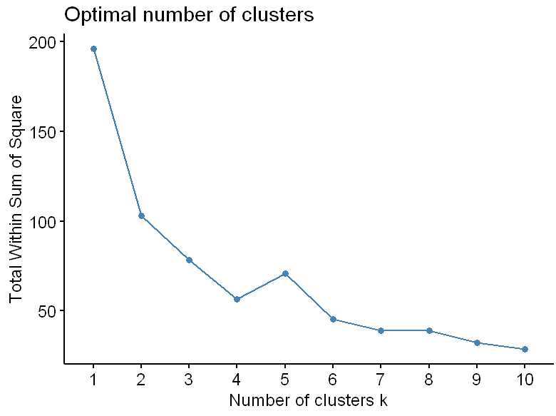

> cat("From the plot, centeres = k = 6, looks like a fair consideration for kmeans clustering!

+ REASON: After k=6, the curve flattens, and do not give any additional information")

From the plot, centeres = k = 6, looks like a fair consideration for kmeans clustering!

REASON: After k=6, the curve flattens, and do not give any additional information

>

> set.seed(037831852)

> kmeans_m2 <- kmeans(Q2_normalized, centers = 6)

> kmeans_m2$cluster

Alabama Alaska Arizona Arkansas California Colorado Connecticut

2 1 5 2 3 3 4

Delaware Florida Georgia Hawaii Idaho Illinois Indiana

4 1 2 4 6 5 4

Iowa Kansas Kentucky Louisiana Maine Maryland Massachusetts

6 4 6 2 6 1 4

Michigan Minnesota Mississippi Missouri Montana Nebraska Nevada

1 6 2 5 6 6 3

New Hampshire New Jersey New Mexico New York North Carolina North Dakota Ohio

6 4 1 5 2 6 4

Oklahoma Oregon Pennsylvania Rhode Island South Carolina South Dakota Tennessee

4 4 4 4 2 6 2

Texas Utah Vermont Virginia Washington West Virginia Wisconsin

5 4 6 4 4 6 6

Wyoming

4

>

> fviz_cluster(kmeans_m2, data=Q2_normalized, main = "K-means Clustering with 6 Clusters", geom = "point", labelsize = 1.5)

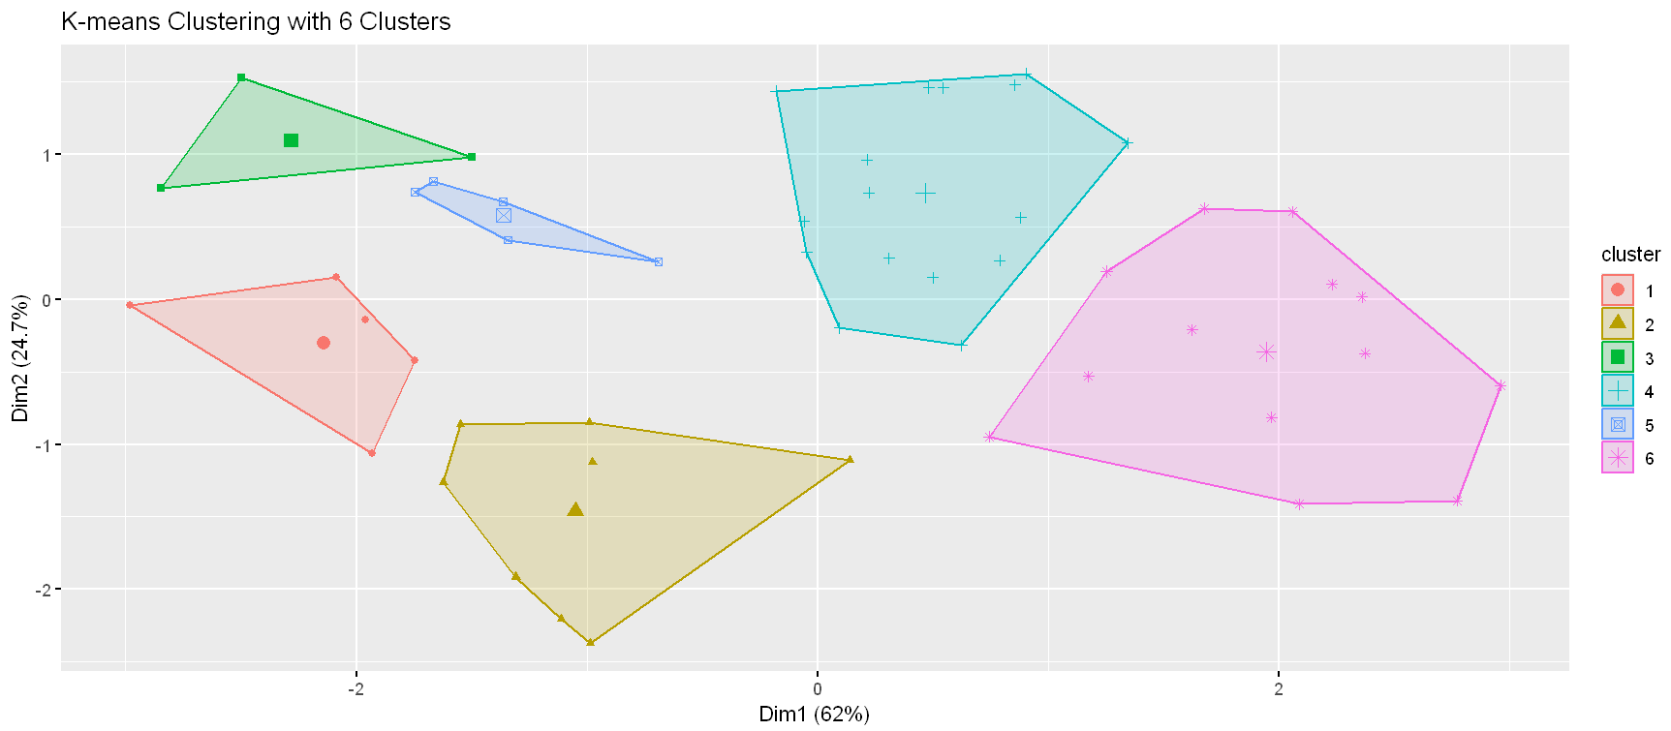

> # also Dendogram splits

> split(rownames(Q2), kmeans_m2$cluster)

$`1`

[1] "Alaska" "Florida" "Maryland" "Michigan" "New Mexico"

$`2`

[1] "Alabama" "Arkansas" "Georgia" "Louisiana" "Mississippi" "North Carolina"

[7] "South Carolina" "Tennessee"

$`3`

[1] "California" "Colorado" "Nevada"

$`4`

[1] "Connecticut" "Delaware" "Hawaii" "Indiana" "Kansas" "Massachusetts"

[7] "New Jersey" "Ohio" "Oklahoma" "Oregon" "Pennsylvania" "Rhode Island"

[13] "Utah" "Virginia" "Washington" "Wyoming"

$`5`

[1] "Arizona" "Illinois" "Missouri" "New York" "Texas"

$`6`

[1] "Idaho" "Iowa" "Kentucky" "Maine" "Minnesota" "Montana"

[7] "Nebraska" "New Hampshire" "North Dakota" "South Dakota" "Vermont" "West Virginia"

[13] "Wisconsin"

>

>

> # c

>

> # Performing Heirarchial Clustering

> d2 = dist(Q2_normalized)

> hc2 <- hclust(d2)

> plot(hc2, main = "Heirarchial Clustering for USArrests data", labels = rownames(Q2), cex = 0.5)

> rect.hclust(hc2, k = 6, border = "red")

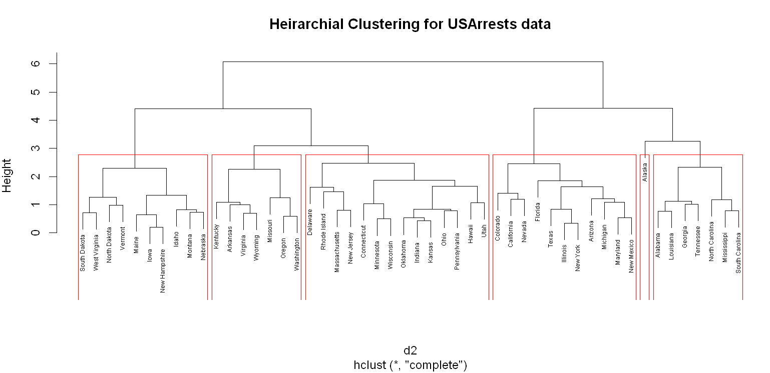

**Q.N. 3)** The penguins dataset included in the palmerpenguins package provides the size measurements for adult foraging penguins near Palmer Station, Antarctica.

a) Access the data and determine its dimension.

b) Omit the missing values from the dataset

c) Choose 50 observations at random from the clean dataset. Please make sure that your results are reproduceable so choose a set.seed () value.

d) Extract the numerical variables and standardize them.

e) Perform the cluster analysis using the K-means clustering and Cluster Dendrogram and identify the members in the clusters.

> # Q3

>

> # a

>

> install.packages("palmerpenguins")

> library(palmerpenguins)

> data(penguins, package = "palmerpenguins")

> Q3 <- penguins

> head(Q3)

# A tibble: 6 × 8

species island bill_length_mm bill_depth_mm flipper_length_mm body_mass_g sex year

*<fct>* *<fct>* *<dbl>* *<dbl>* *<int>* *<int>* *<fct>* *<int>*

1 Adelie Torgersen 39.1 18.7 181 3750 male 2007

2 Adelie Torgersen 39.5 17.4 186 3800 female 2007

3 Adelie Torgersen 40.3 18 195 3250 female 2007

4 Adelie Torgersen NA NA NA NA NA 2007

5 Adelie Torgersen 36.7 19.3 193 3450 female 2007

6 Adelie Torgersen 39.3 20.6 190 3650 male 2007

> dim(Q3)

[1] 344 8

>

>

> # b

>

> sum(is.na(Q3))

[1] 19

> Q3_clean <- na.omit(Q3)

> head(Q3_clean)

# A tibble: 6 × 8

species island bill_length_mm bill_depth_mm flipper_length_mm body_mass_g sex year

*<fct>* *<fct>* *<dbl>* *<dbl>* *<int>* *<int>* *<fct>* *<int>*

1 Adelie Torgersen 39.1 18.7 181 3750 male 2007

2 Adelie Torgersen 39.5 17.4 186 3800 female 2007

3 Adelie Torgersen 40.3 18 195 3250 female 2007

4 Adelie Torgersen 36.7 19.3 193 3450 female 2007

5 Adelie Torgersen 39.3 20.6 190 3650 male 2007

6 Adelie Torgersen 38.9 17.8 181 3625 female 2007

> dim(Q3_clean)

[1] 333 8

>

> # c

>

> set.seed(037831852)

> i = sample(nrow(Q3_clean), 50)

> Q3_50 <- Q3_clean[i,]

> head(Q3_50)

# A tibble: 6 × 8

species island bill_length_mm bill_depth_mm flipper_length_mm body_mass_g sex year

*<fct>* *<fct>* *<dbl>* *<dbl>* *<int>* *<int>* *<fct>* *<int>*

1 Adelie Torgersen 38.8 17.6 191 3275 female 2009

2 Chinstrap Dream 50.6 19.4 193 3800 male 2007

3 Adelie Biscoe 37.9 18.6 172 3150 female 2007

4 Gentoo Biscoe 47.4 14.6 212 4725 female 2009

5 Adelie Biscoe 42.2 19.5 197 4275 male 2009

6 Adelie Dream 42.2 18.5 180 3550 female 2007

> dim(Q3_50)

[1] 50 8

> names(Q3_50)

[1] "species" "island" "bill_length_mm" "bill_depth_mm"

[5] "flipper_length_mm" "body_mass_g" "sex" "year"

>

>

> # d

>

> # extracting the numerical data (EXCLUDING YEAR COLUMN)

> data3_numerical_columns <- Q3_50[,c(3,4,5,6)]

> # Standardizing using Zscore

> Q3_normalized <- scale(data3_numerical_columns)

> head(Q3_normalized)

bill_length_mm bill_depth_mm flipper_length_mm body_mass_g

[1,] -0.9249124 0.06955183 -0.5380717 -1.0863358

[2,] 1.3776122 1.03257711 -0.3934287 -0.3634888

[3,] -1.1005287 0.60456588 -1.9121794 -1.2584422

[4,] 0.7531987 -1.53549032 0.9806790 0.9100988

[5,] -0.2614731 1.08607852 -0.1041429 0.2905157

[6,] -0.2614731 0.55106447 -1.3336077 -0.7077016

>

>

> # e

>

> library(factoextra)

> fviz_nbclust(Q3_normalized, kmeans, method = "wss")

> cat("From the plot, centeres = k = 4, looks like a fair consideration for kmeans clustering!

+ REASON: After k=3, the curve flattens, and do not give any additional information")

From the plot, centeres = k = 4, looks like a fair consideration for kmeans clustering!

REASON: After k=3, the curve flattens, and do not give any additional information

>

> set.seed(037831852)

> kmeans_m3 <- kmeans(Q3_normalized, centers = 3)

> kmeans_m3$cluster

[1] 3 3 3 2 3 3 1 3 1 3 3 3 3 3 3 1 3 3 3 2 3 3 2 2 3 3 2 3 2 3 1 1 1 3 3 3 3 1 3 3 3 1 3 3 3 3 3 3

[49] 3 3

>

> fviz_cluster(kmeans_m3, data=Q3_normalized, main = "K-means Clustering with 3 Clusters", geom = "point", labelsize = 1.5)

> # also Dendogram splits

> split(Q3_50$species, kmeans_m3$cluster)

$`1`

[1] Gentoo Gentoo Gentoo Gentoo Gentoo Gentoo Gentoo Gentoo

Levels: Adelie Chinstrap Gentoo

$`2`

[1] Gentoo Gentoo Gentoo Gentoo Gentoo Gentoo

Levels: Adelie Chinstrap Gentoo

$`3`

[1] Adelie Chinstrap Adelie Adelie Adelie Adelie Adelie Adelie Chinstrap

[10] Adelie Adelie Chinstrap Chinstrap Adelie Adelie Adelie Chinstrap Adelie

[19] Chinstrap Chinstrap Adelie Adelie Adelie Adelie Adelie Adelie Adelie

[28] Chinstrap Adelie Chinstrap Adelie Adelie Adelie Adelie Adelie Chinstrap

Levels: Adelie Chinstrap Gentoo

> # Performing Heirarchial Clustering

> d3 = dist(Q3_normalized)

> # also

> # Performing Heirarchial Clustering

> d3 = dist(Q3_normalized)

> hc3 <- hclust(d3)

> plot(hc3, main = "Heirarchial Clustering for Penguin data", labels = Q3_50$species ,cex = 0.5)

> rect.hclust(hc3, k = 3, border = "red")

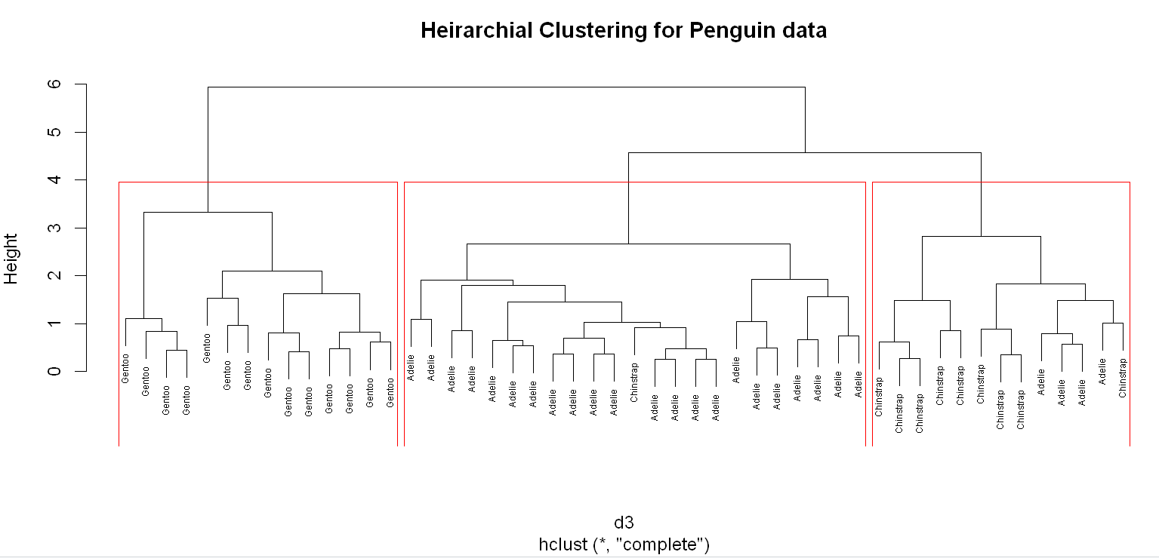

**Q.N. 4)** The diabetes data set provided with this assignment consists of 520 observations on 17 features. The target variable is the Class variable which can take on two values, Positive and Negative. All but one of the features are binary. The nonbinary feature is the Age feature.

a) Import the dataset in R and print the variable names.

b) Split the data set in training and test set with 70% in training and 30% in test set.

c) Creating a Decision Tree Model using the training data.

d) Predict the response on the test data and produce a confusion matrix comparing the test labels to the predicted labels. What is the Accuracy rate?

> # Q4

>

> # a

>

> Q4 <- read.csv("diabetes.csv")

> head(Q4)

Age Gender Polyuria Polydipsia weightloss weakness Polyphagia Genital_thrush visual_blurring

1 40 Male No Yes No Yes No No No

2 58 Male No No No Yes No No Yes

3 41 Male Yes No No Yes Yes No No

4 45 Male No No Yes Yes Yes Yes No

5 60 Male Yes Yes Yes Yes Yes No Yes

6 55 Male Yes Yes No Yes Yes No Yes

Itching Irritability delayed_healing partial_paresis muscle_stiffness Alopecia Obesity class

1 Yes No Yes No Yes Yes Yes Positive

2 No No No Yes No Yes No Positive

3 Yes No Yes No Yes Yes No Positive

4 Yes No Yes No No No No Positive

5 Yes Yes Yes Yes Yes Yes Yes Positive

6 Yes No Yes No Yes Yes Yes Positive

> dim(Q4)

[1] 520 17

> names(Q4)

[1] "Age" "Gender" "Polyuria" "Polydipsia" "weightloss"

[6] "weakness" "Polyphagia" "Genital_thrush" "visual_blurring" "Itching"

[11] "Irritability" "delayed_healing" "partial_paresis" "muscle_stiffness" "Alopecia"

[16] "Obesity" "class"

>

>

> # b

>

> install.packages("caret")

> library(caret)

> set.seed(037831852)

> train_index <- createDataPartition(Q4$class, p=0.7, list = FALSE)

> train <- Q4[train_index,]

> test <- Q4[-train_index,]

> # dim(Q4)

> # dim(train)

> # dim(test)

>

>

> # c

>

> install.packages("rpart")

> library(rpart)

> install.packages("rpart.plot")

> library(rpart.plot)>

> tree_model4 <- rpart(train$class~., data = train, method = "class")

> tree_model4

n= 364

node), split, n, loss, yval, (yprob)

* denotes terminal node

1) root 364 140 Positive (0.38461538 0.61538462)

2) Polyuria=No 187 56 Negative (0.70053476 0.29946524)

4) Gender=Male 137 18 Negative (0.86861314 0.13138686)

8) Polydipsia=No 122 7 Negative (0.94262295 0.05737705) *

9) Polydipsia=Yes 15 4 Positive (0.26666667 0.73333333) *

5) Gender=Female 50 12 Positive (0.24000000 0.76000000)

10) Alopecia=Yes 10 3 Negative (0.70000000 0.30000000) *

11) Alopecia=No 40 5 Positive (0.12500000 0.87500000) *

3) Polyuria=Yes 177 9 Positive (0.05084746 0.94915254)

6) Age>=64 23 7 Positive (0.30434783 0.69565217)

12) Polydipsia=No 10 3 Negative (0.70000000 0.30000000) *

13) Polydipsia=Yes 13 0 Positive (0.00000000 1.00000000) *

7) Age< 64 154 2 Positive (0.01298701 0.98701299) *

>

> plot(tree_model4)

> text(tree_model4, use.n = TRUE, cex = 0.7, col = "red")

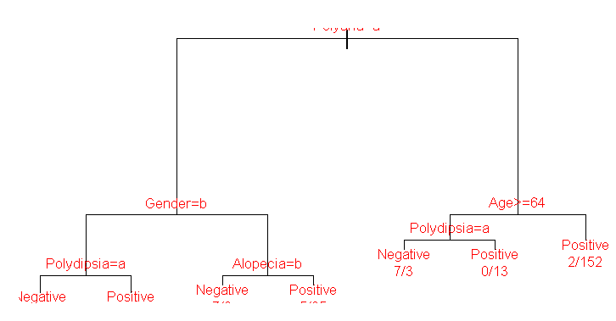

> printcp(tree_model4)

Classification tree:

rpart(formula = train$class ~ ., data = train, method = "class")

Variables actually used in tree construction:

[1] Age Alopecia Gender Polydipsia Polyuria

Root node error: 140/364 = 0.38462

n= 364

CP nsplit rel error xerror xstd

1 0.535714 0 1.00000 1.00000 0.066299

2 0.185714 1 0.46429 0.57143 0.056432

3 0.050000 2 0.27857 0.35714 0.046911

4 0.028571 3 0.22857 0.26429 0.041181

5 0.014286 4 0.20000 0.24286 0.039657

6 0.010000 6 0.17143 0.23571 0.039128

> plotcp(tree_model4)

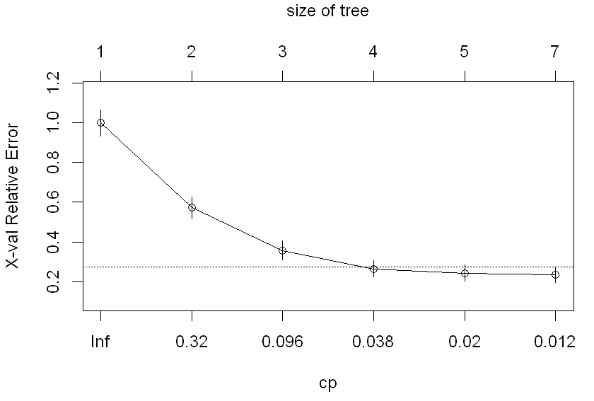

> rpart.plot(tree_model4, type = 2, extra = 101, tweak = 1, box.palette = "skyblue")

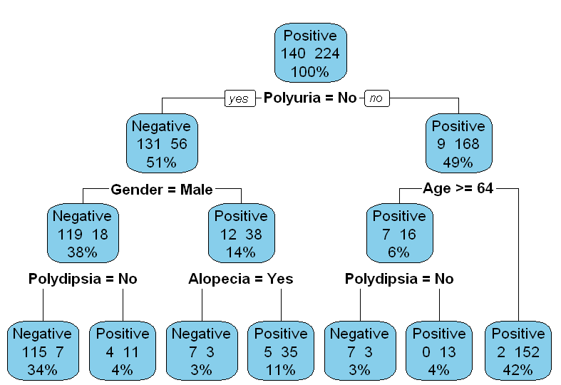

> # d

>

> actual_class <- test$class

> # actual_class

>

> predicted = predict(tree_model4, test)

> # predicted

> predicted_class <- ifelse(predicted[, "Positive"] > 0.5, "Positive", "Negative")

> # predicted_class

>

> # confusion matrix

> conf_matrix <- table(Predicted = predicted_class, Actual = actual_class)

> conf_matrix

Actual

Predicted Negative Positive

Negative 53 10

Positive 7 86

>

> # Accuracy

> accuracy <- sum(predicted_class == actual_class) / length(actual_class)

> accuracy

[1] 0.8910256

> cat("Accuracy: 89.10%")

Accuracy: 89.10%